**Aim**: Simulate star topology and check the connectivity between devices.

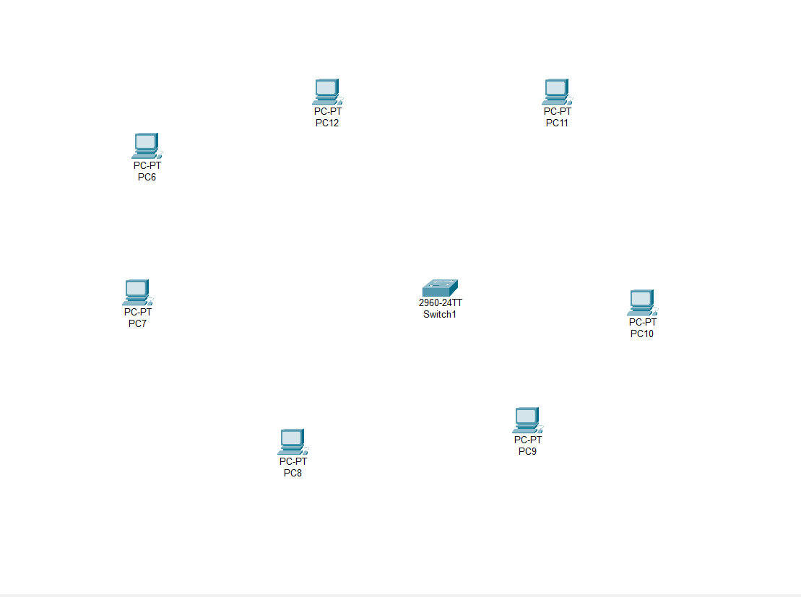Step-1:- Take One Switch and Multiple PC’s.

Step-2 :- Now Connect them using Copper Straight Connection Cabel.

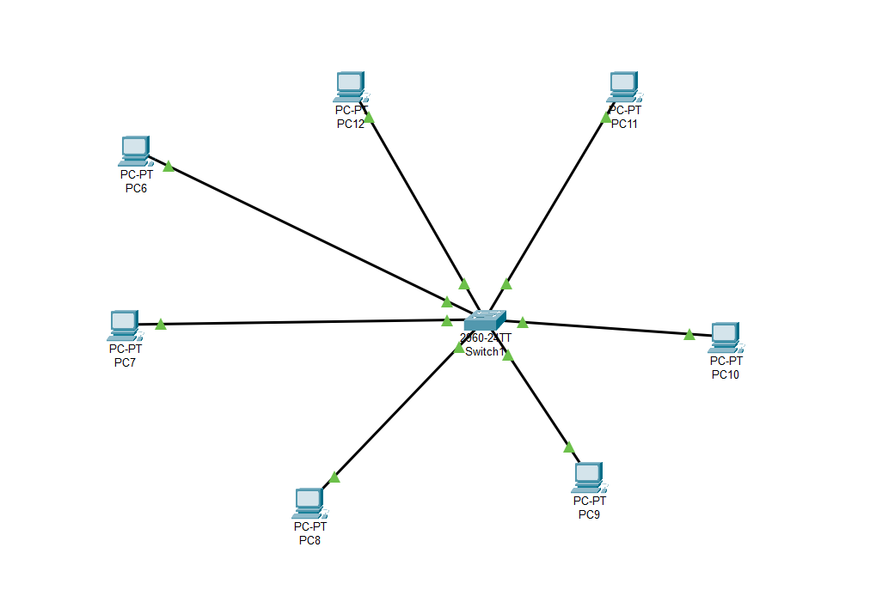

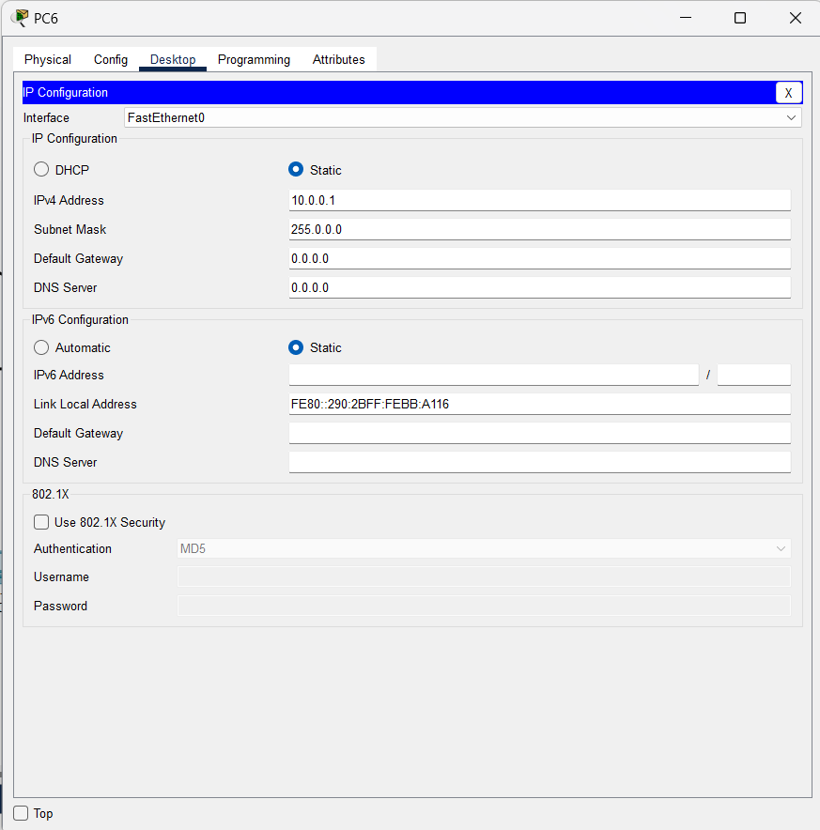Step – 3 :- Now Configure all the PC’s with Different IP Address and Same subnet mask

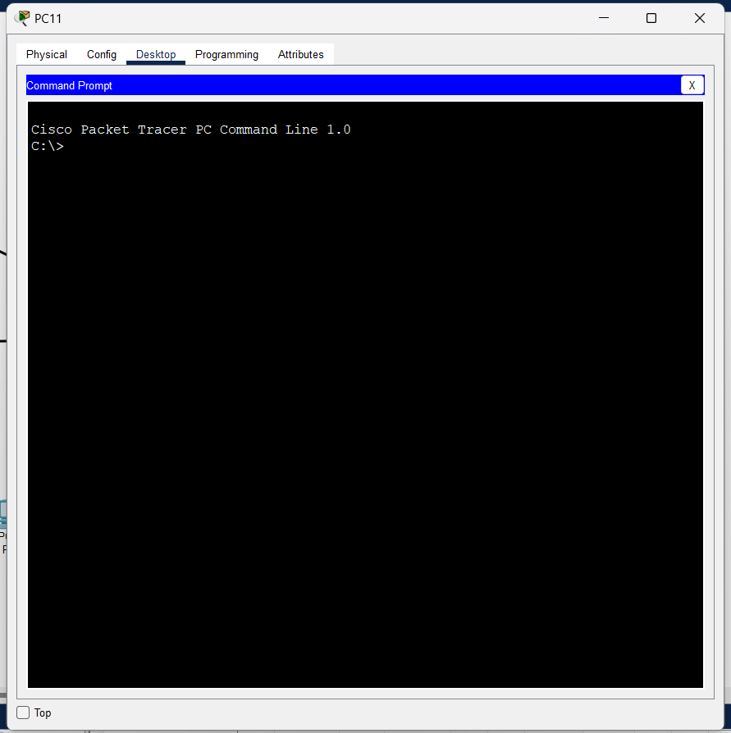Step – 4 :- Now open command prompt of any one of that PC’s

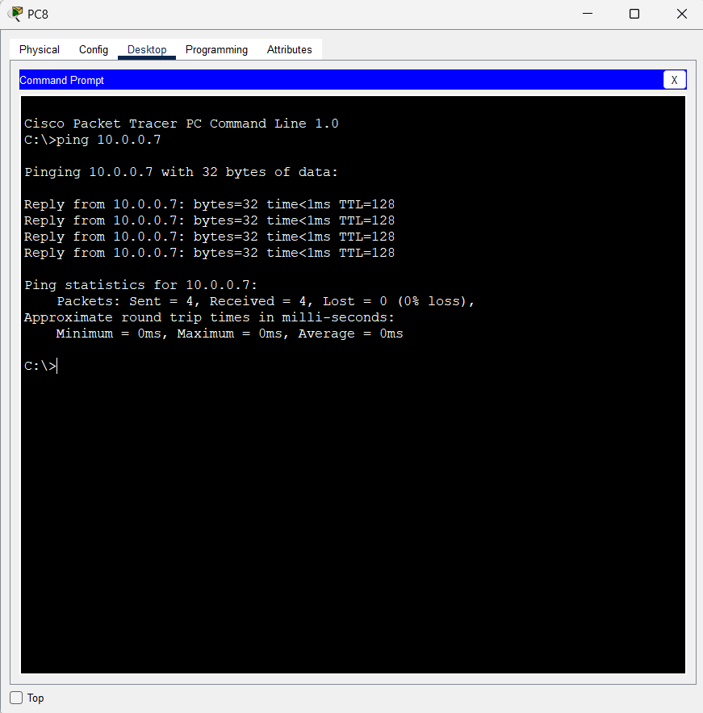Step – 5 :- Now run command “ping ip_address” where ip_address is your destination ip address.

It shows the successful connection.

**Conclusion:-**

By Performing this Experiment, I came to Know about star topology how to configure the IP address and ho to check the successful connection between two pc’s—and learnt how the topologies are actually implemented.